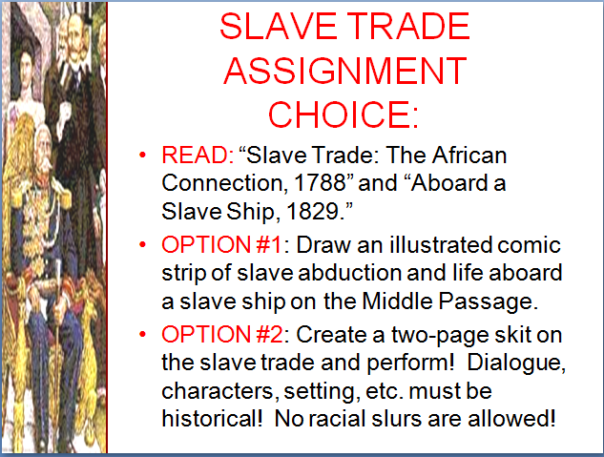

Slave Trade:

the African Connection, ca 1788
The labor-intensive agriculture of the New World demanded a large workforce. Crops such as sugar cane, tobacco and cotton required an unlimited and cheap supply of strong backs to assure timely production for European sale. Slaves from Africa offered the solution. The slave trade between Western Africa and the America's reached its peak in the mid-18th century when it is estimated that over 80,000 Africans annually crossed the Atlantic to spend the rest of their lives in chains. Of those who survived the voyage, the final destination of approximately 40% was the Caribbean Islands. 38% ended up in Brazil, 17% in Spanish America and 6% in the United States.
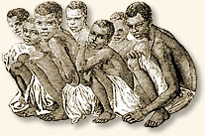
Young boys wait to be loaded
aboard a slave ship
A slave's journey to a life of servitude often began in the interior of Africa with his or her capture as a prize of war, as tribute given by a weak tribal state to a more powerful one, or by outright kidnapping by local traders. European slave traders rarely ventured beyond Africa's coastal regions. The African interior was riddled with disease, the natives were often hostile and the land uncharted. The Europeans preferred to stay in the coastal region and have the natives bring the slaves to them.
"Most of the Negroes shipped off from the coast of Africa are kidnapped."
Dr. Alexander Falconbridge served as the surgeon aboard a number of slave ships that sailed in the late 1700s. He described his experiences in a popular book published in 1788. He became active in the Anti-Slavery Society and was appointed Governor of a colony established for freed slaves in Sierra Leone. We join his story as he describes the process through which the native African looses his freedom:
“of the Negroes shipped off from the coast of Africa, most are kidnapped. But the extreme care taken by the black traders to prevent the Europeans from gaining any intelligence of their modes of proceeding; the great distance inland from whence the Negroes are brought; and our ignorance of their language (with which, very frequently, the black traders themselves are equally unacquainted), prevent our obtaining such information as we could wish. I have, however, by means of occasional inquiries, made through interpreters, procured some intelligence relative to the point. . . .
While I was in employ on board one of the slave ships, a Negro informed me that being one evening invited to drink with some of the black traders, upon his going away, they attempted to seize him. As he was very active, and got out of their hands. He was, however, prevented from effecting his escape by a large dog, which laid hold of him, and compelled him to submit. These creatures are kept by many of the traders for that purpose; and being trained to the inhuman sport, they appear to be much pleased with it.
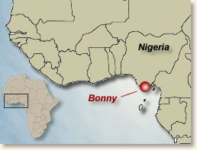
A man and his son, according to their own information, were seized by professed kidnappers, while they were planting yams, and sold for slaves. This likewise happened in the interior parts of the country, and after passing through several hands, they were purchased for the ship to which I belonged. It frequently happens that those who kidnap others are themselves, in their turns, seized and sold.

The preparations made at Bonny by the black traders, upon setting out for the fairs which are held up the country, are very considerable. From twenty to thirty canoes, capable of containing thirty or forty Negroes each, are assembled for this purpose; and such goods put on board them as they expect will be wanted for the purchase of the number of slaves they intend to buy.
When their loading is completed, they commence their voyage, with colors flying, and music playing; and in about ten or eleven days, they generally return to Bonny with full cargoes. As soon as the canoes arrive at the trader's landing place, the purchased Negroes are cleaned, and oiled with palm-oil; and on the following day they are exposed for sale to the captains.
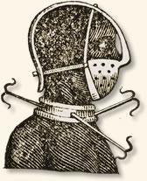
A device used to control
unruly slaves
When the Negroes, whom the black traders have to dispose of, are shown to the European purchasers, they first examine their age. They then inquire into the state of their health, if they are afflicted with any infirmity, or are deformed, or have bad eyes or teeth; if they are lame, or weak in their joints, or distorted in the back, or of a slender make, or are narrow in the chest; in short, if they have been, or are afflicted in any manner, so as to render them incapable of much labor; if any of the foregoing defects are discovered in them, they are rejected. But if approved of, they are generally taken on board the ship the same evening.
The traders frequently beat those Negroes which are objected to by the captains, and use them with great severity. It matters not whether they are refused on account of age, illness, deformity, or for any other reason.
As soon as the wretched Africans, purchased at the fairs, fall into the hands of the black traders, they experience an earnest of those dreadful sufferings which they are doomed in future to undergo. . . . They are brought from the places where they are purchased to Bonny, etc. in canoes; at the bottom of which they lie, having their hands tied with a kind of willow twigs, and a strict watch is kept over them. Their usage in other respects, during the time of the passage, which generally lasts several days, is equally cruel. Their allowance of food is so scanty, that it is barely sufficient to support nature. They are, besides, much exposed to the violent rains which frequently fall here, being covered only with mats that afford but a slight defense; and as there is usually water at the bottom of the canoes, from their leaking, they are scarcely ever dry."
References:
This eyewitness account appears in Falconbridge, Alexander, An Account of the Slave Trade on the Coast of Africa (1788); Curtin, Phillip D. Atlantic Slave Trade (1969); Matheson, William Law, Great Britain and the Slave Trade, 1839-1865 (1967).
How To Cite This Article:
"Slave Trade: the African Connection, ca 1788" EyeWitness to History, www.eyewitnesstohistory.com (2007).

EyeWitnesstoHistory.com

Aboard a Slave Ship, 1829
In 1807 the British passed a bill prohibiting the slave trade. In January the following year the United States followed suit by outlawing the importation of slaves. The acts did nothing to curtail the trade of slaves within the nation's borders, but did end the overseas commerce in slaves. To enforce these laws, Britain and the United States jointly patrolled the seas off the coast of Africa, stopping suspected slave traders and confiscating the ship when slaves were found. The human cargo was then transported back to Africa.
Conditions aboard the slave ships were wretched. Men, women and children crammed into every available space, denied adequate room, food or breathing space. The stench was appalling - the atmosphere inhumane to say the least. The Reverend Robert Walsh served aboard one of the ships assigned to intercept the slavers off the African coast. On the morning of May 22, 1829, a suspected slaver was sighted and the naval vessel gave chase. The next day, a favorable wind allowed the interceptor to gain on its quarry and approach close enough to fire two shots across her bow. The slaver heaved to and an armed party from the interceptor scrambled aboard her. We join Reverend Walsh's account as he boards the slave ship:
" I went on board with the officers. When we mounted her decks we found her full of slaves. She was called the Feloz, commanded by Captain Jose' Barbosa. She was a very broad-decked ship, and behind her foremast was a large, formidable gun, which turned on a broad circle of iron, on deck, and which enabled her to act as a pirate if her slaving failed.
She had taken in, on the coast of Africa, 336 males and 226 females, making in all 562, and had been out seventeen days, during which she had thrown overboard 55. The slaves were all inclosed under grated hatchways between decks. The space was so low that they sat between each other's legs and [were] stowed so close together that there was no possibility of their lying down or at all changing their position by night or day. As they belonged to and were shipped on account of different individuals, they were all branded like sheep with the owner's marks of different forms, 'burnt with the red-hot iron.'
Over the hatchway stood a ferocious-looking fellow with a scourge of many twisted thongs in his hand, who was the slave driver of the ship, and whenever he heard the slightest noise below, he shook it over them and seemed eager to exercise it. I was quite pleased to take this hateful badge out of his hand, and I have kept it ever since as a horrid memorial of reality, should I ever forget the scene I witnessed…
As soon as the poor creatures saw us looking down at them, their dark faces brightened up. They perceived something of sympathy and kindness in our looks which they had not been accustomed to, and, feeling instinctively that we were friends, they immediately began to shout and clap their hands. One or two had picked up a few Portuguese words, and cried out, "Viva! Viva!" The women were particularly excited. They all held up their arms, and when we bent down and shook hands with them, they could not contain their delight; they endeavored to scramble up on their knees, stretching up to kiss our hands, and we understood that they knew we were come to liberate them. Some, however, hung down their heads in apparently hopeless dejection; some were starving, and some, particularly children, seemed dying.
Oh how it was possible for such a number of human beings to exist, packed up and wedged together as tight as they could cram! In low cells three feet high, shut out from light or air, and this when the thermometer at 89'. We also found manacles and fetters of different kinds, but it appears that they had all been taken off before we boarded.
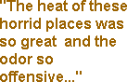
The heat of these horrid places was so great and the odor so offensive that it was quite impossible to enter them, even had there been room. They were measured as above when the slaves had left them. The officers insisted that the poor suffering creatures should be admitted on deck to get air and water. This was opposed by the mate of the slaver, who declared they would murder them all. The officers, however, insisted, and the poor beings were all turned up together. It is impossible to conceive the effect of this eruption - 517 fellow creatures of all ages and sexes, some children, some adults, some old men and women, all in a state of total nudity, scrambling out together to taste the luxury of a little fresh air and water. They came swarming up like bees from the aperture of a hive till the whole deck was crowded to suffocation front stem to stern, so that it was impossible to imagine where they could all have come from or how they could have been stowed away. On looking into the places where they had been crammed, there were found some children next the sides of the ship, in the places most remote from light and air. The little creatures seemed indifferent as to life or death, and when they were carried on deck, many of them could not stand.
After enjoying for a short time the unusual luxury of air, some water was brought; it was then that the extent of their sufferings was exposed in a fearful manner. They all rushed like maniacs towards it. No entreaties or threats or blows could restrain them; they shrieked and struggled and fought with one another for a drop of this precious liquid, as if they grew rabid at the sight of it.
It was not surprising that they should have endured much sickness and loss of life in their short passage. They had sailed from the coast of Africa on the 7th of May and had been out but seventeen days, and they had thrown overboard no less than fifty-five, who had died of dysentery and other complaints in that space of time, though they had left the coast in good health. Indeed, many of the survivors were seen lying about the decks in the last stage of emaciation and in a state of filth and misery not to be looked at. Even-handed justice had visited the effects of this unholy traffic on the crew who were engaged in it. Eight or nine had died, and at that moment six were in hammocks on board, in different stages of fever. This mortality did not arise from want of medicine.
Oh my horror at what I saw! The height sometimes between decks was only eighteen inches, so that the unfortunate beings could not turn round or even on their sides, and here they are usually chained to the decks by the neck and legs. In such a place the sense of misery and suffocation is so great that the Negroes are driven to a frenzy.
A living man was sometimes dragged up, and his companion was a dead body; sometimes of the three attached to the same chain, one was dying and another dead. The tumult they had heard was the frenzy of those suffocating wretches in the last stage of fury and desperation, struggling to free themselves. When they were all dragged up, nineteen were irrecoverably dead. Many destroyed one another in the hopes of procuring room to breathe; men strangled those next them, and women drove nails into each other's brains. Many unfortunate creatures on other occasions took the first opportunity of leaping overboard and getting rid, in this way, of an intolerable life."
References:
Walsh, Robert, Notices of Brazil in 1828 and 1829 (1831).
How To Cite This Article:
"Aboard a Slave Ship, 1829," EyeWitness to History, www.eyewitnesstohistory.com (2000).

