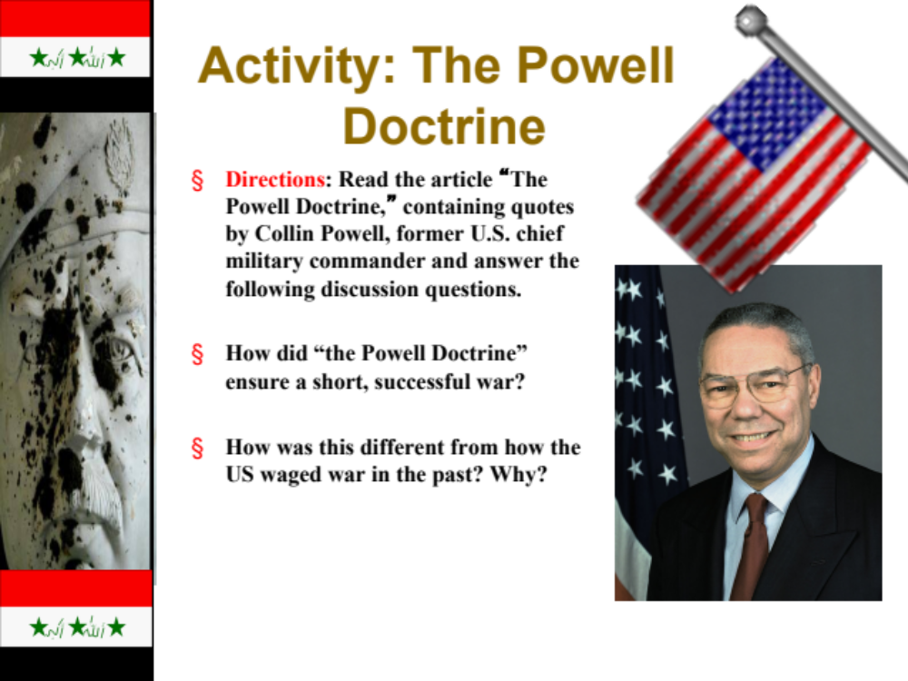
The Gulf War Activity
THE POWELL DOCTRINE
Background, Application and Critical Analysis
By Doug DuBrin, an English/History teacher and editor/ writer.
Overview:
After the end of Persian Gulf War in 1991, Colin Powell, then chairman of the Joint Chiefs of Staff, outlined his vision for efficient and decisive military action. His plan is now referred to as the Powell Doctrine, although there is not an actual formal document named as such. Powell, currently the U.S. secretary of state, has recently invoked the Doctrine in articulating the justifications for the Bush administration's preparations for war in Iraq. Essentially, the Doctrine expresses that military action should be used only as a last resort and only if there is a clear risk to national security by the intended target; the force, when used, should be overwhelming and disproportionate to the force used by the enemy; there must be strong support for the campaign by the general public; and there must be a clear exit strategy from the conflict in which the military is engaged.
Powell based this strategy for warfare in part on the views held by his former boss in the Reagan administration, Secretary of Defense Caspar Weinberger, and also on his own experience as a major in Vietnam. That protracted campaign, in Powell's view, was representative of a war in which public support was flimsy, the military objectives were not clear, overwhelming force was not used consistently, and an exit strategy was ill defined.
Introduction: Colin Powell was the former was the chief military commander of the U.S. forces and later a chief diplomat. Born in New York in 1937, he was raised in the South Bronx. He spent 35 years in the military and is a decorated Vietnam veteran. Politically, Powell is thought to be a moderate Republican, but he has been sought by both Republicans and Democrats alike to run for president. Powell also is the highest-ranking African American in U.S. political history. Internationally, Powell is respected as an articulate, confident, and even-minded statesman. For the last several months he has been actively involved in an international diplomacy campaign that has required him to meet frequently with leaders and dignitaries from around the globe.
THE POWELL DOCTRINE
QUOTES
Then Chairman of the Joints Chiefs of Staff Colin Powell, when asked about his military strategy against the Iraqi army in the Persian Gulf War of 1991:
"First we're going to cut it off, then we're going to kill it."

Powell, from his speech "U.S. Forces: The Challenges Ahead" 1992 :
"We owe it to the men and women who go in harm's way to make sure that this is always the case and that their lives are not squandered for unclear purposes."
"We must not, for example, send military forces into a crisis with an unclear mission then cannot accomplish -such as we did when we sent the U.S. Marines into Lebanon in 1983. We inserted those proud warriors into the middle of a five-faction civil war complete with terrorists, hostage-takers, and a dozen spies in every camp, and said, 'Gentlemen, be a buffer.' The results were 241 Marines and Navy personnel killed and a U.S. withdrawal from the troubled area."

Charles Krauthammer, Washington Post columnist, April 2002:
"The Powell Doctrine found its ultimate expression in the Gulf War. The idea was not to match Iraqi power but to entirely overwhelm it in planes, tanks, technology, manpower and will. That would make the war short and make the victory certain. It did. Today, the Powell Doctrine seems obvious, but it was not at the time. For decades, the United States had followed a policy of proportionality: restraint because of the fear of escalation. It was under this theory that Maj. Powell watched his men bleed and die purposely in Vietnam."
Ruth Rosen, San Francisco Chronicle columnist, March 2003:
"The impending war in Iraq, however, arguably meets only one criterion of the Powell Doctrine. Weapons inspectors have just begun their work, which is why France, Russia, and China argue that war is not yet a last resort. Public support for a war in Iraq is hardly strong. In the most recent New York Times/CBS News poll, while a majority of Americans support the use of force as an option, 59 percent want to give the United Nations and weapons inspectors more time. The divided opinion reflects the lack of a well-defined national interest in going to war now. The Bush administration has tried to portray a pre-emptive war against as essential to the war on terrorism, but the evidence of the 'links' between Saddam Hussein and al Qaeda is highly questionable."
FOLLOW-UP QUESTIONS--ANSWER THE FOLLOWING CRITICAL THINKING QUESTIONS IN COMPLETE SENTENCES:
- What were the major tenets of the “Powell Doctrine”? Why was this a relatively new idea in American military history?

- What armed conflicts prior to the Powell Doctrine either reflected his philosophy on warfare (or contradicted it)? In other words, what historical precedents, besides Vietnam, perhaps helped formulate Powell's line of thinking?

- Is the Powell Doctrine ultimately a more humane way to conduct warfare, even though the use of force it entails is designed to be overwhelming and extraordinarily destructive?

- Do you see President Truman's decision to drop the atom bombs on Japan to end World War II as being aligned with the tenets of the Powell Doctrine?

- What are some potential problems you foresee with the implementation of the Powell Doctrine in military affairs?

Works Cited:
Excerpts from "Colin Powell, 'U.S. Forces: The Challenges Ahead,'" Foreign Affairs Winter 1992 (qtd. in <http://academic.brooklyn.cuny.edu/history/johnson/powell/htm>).
Krauthammer, Charles. "What Happened to the Powell Doctrine?" Washington Post 20 Apr. 2002.
Malone, Jim. "What will 'Powell Doctrine' foreign policy mean?" Journal of Aerospace and Defense Industry News 23 Jan. 2003 http://www.aerotechnews.com/starc/2001/012301/powell_doctrine.html.
"Powell Doctrine." Wikipedia <http://www.wikipedia.org/wiki/PowellDoctrine>.
Rosen, Ruth. "Whatever Happened to the Powell Doctrine?" San Francisco Chronicle (qtd. in the History News Network 3 March 2003 http://hnn.us.articles/1290.html).
Author Doug DuBrin taught Social Studies and Literature at the Arizona School for the Arts for 4 years. Before that he taught at the Near North Montessori School and the Monroe Middle School in Rochester, NY. He has a BA from the University of Rochester and a MA from the University of Illinois at Chicago.

