D- DAY INVASION LETTERS

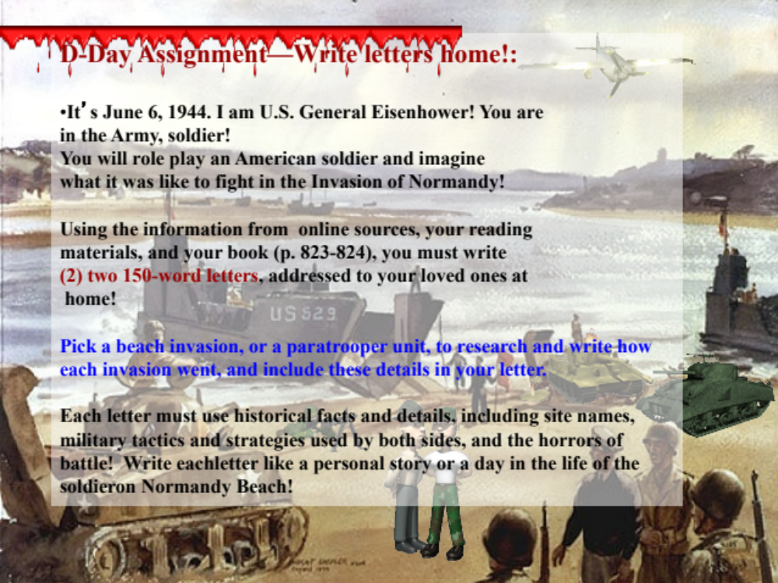

By June 1944, the Allies had finally, after protracted and bitter fighting,
overthrown Mussolini and driven the Germans out of Italy. The critical task of
retaking “Fortress Europe” from Hitler remained.

Supreme Allied Commander General Dwight D. Eisenhower encouraged the
troops who would storm the beaches of France in the Allied D-Day attack at
Normandy, “You are about to embark upon a great crusade. The eyes of the
world are upon you. The hopes and prayers of liberty-loving people
everywhere march with you. You will bring about the destruction of the
German war machine, the elimination of Nazi tyranny over the oppressed
peoples of Europe, and security for ourselves in a free world.”

The D-Day attack, which initiated the full-scale invasion of Europe, was the
largest and most powerful invasion force in history and a feat of complex
military organization, supply, and coordination. For months in advance, Allied
bombers pounded German defenses along the Normandy coast, and on June
6, 1944, combined Allied forces landed. General Dwight D. Eisenhower,
Supreme Allied Commander, oversaw a massive offensive, which included
5,000 ships and 90,000 American, British, and Canadian troops. Some 20,000
men were dropped into France by parachute and glider.

Code-named Operation Overlord, the invasion surprised the Germans, who
had been led to believe through calculated leaks, decoys, and deceptions
that the invasion would take place elsewhere. By nightfall, Allied troops were
firmly entrenched on French soil, and it was the beginning of the end for the
Axis. In late August, Allied forces liberated Paris, which had been in German
hands since 1940.

Generals Eisenhower, Montgomery, and Bradley knew this invasion was risky, and that many causalities were possible.
THE DECEPTION: the Allies used a litany of spie to deceive the Germans into thinking that the invasion would take place at a location to the north of Normandy. A fictitious army located at the city of Dover, which was directly cross the Channel from Chalais where the Germans were expecting the invasion, enhanced this idea. The spies had effectively convinced the Germans that Normandy was just a diversion.

FRENCH RESISTANCE: Certain French citizens, opposed to German occupation, were vital to the success of the invasion by sabotaging railroads and bridges prior to the invasion.

AIRBORNE ASSAULT: Two American Airborne unts (82nd and 101st) were to drop into France, behind German lines. This was done in order to prevent German reinforcements from getting to the beaches. Prior to the operations, it as estimated that 70% of these men were going to die. Despite the fact that men were scattered all over the countryside, the airborne drops were considered a success. In addition, the British were part of this aspect of the assault , using plywood gliders to land in Normandy with a minimum amount of noise.

BEACH ASSAULT- Using the newly crafted Higgins Beach Landing Craft, American Units hit Omaha Beach at 6:31am. There were five beaches code named: Omaha, Utah, Juno, Sword, and Gold. The first Americans to land were from the Maryland/Virginia based 29t division. The first unit, the 116th Infantry Division, suffered 97% casualties. Many of these men died before even reaching the shore.

RANGERS- Some of the 2nd and 5th Ranger Battalions scaled the vliffs of Pointe du Hoc to disable the 155mm Howitxers that were reported to be above Utah Beach. After scaling the cliffs without safety harnesses, they discovered the guns had been moved. Two Rangers moved inland, and found and destroyed the guns before 9:00am.

MOVING INLAND- After facing the bloody combat of the beach assault the soldiers moved inland facing more difficulties. The Normandy countryside was riddled with large hedgerows that had been built by farmers to contain their cattle. These large earthen walls provided cover for the Germans. Frequently it would take an entire day to overtake one hedgerow, at the cost of many Allied lives.

Operation Overlord
DIPLOMACY
• _FDR and Churchill 1942
• _Operation Torch
• _Relationship between Eisenhower, Churchill, FDR and DeGaulle
• _Soviet influence

THE PLANNING
• _Eisenhower Leads
• _Patton passed over
• _Montgomery and British reaction
• _Interaction between Americans and British High Command

THE BUILD-UP OF MEN
• _The number of American, Canadian, and Polish Troops in England (over 3 million)
• _The interaction between American men and the British people
• _The interaction between American men and British soldiers
• _The make-up of the American Force
o Small towns/big city/cross section of America
o National Guard units/regular Army
o 29th Division (Maryland, Virginia, Pennsylvania) National Guard units and 1st Infantry
o Airborne units
o American 82nd
o British 6th Airborne
• _The Deception
o Double agents convinced Germans Normandy was diversionary invasion site.
o Agent, code named “Garbo,” most trusted double agent
o “BIGOT” is code word for the top security clearance used for the invasion.
o Fake army placed at Dover, where Germans think the invasion will come
o Patton is in charge of this “army”, and is called “FUSAG.”
o Rubber trucks and tanks used to deceive Germans; believe that because Patton is there the Allies will attack at Calais
o French resistance forces pass on information to the Allies.
o Invasion delayed one day due to storm in the Channel; Allies launch campaign on the 6th rather than waiting two weeks for right moon and tidal conditions
• _The Air Drop
o Two American and one British Airborne units are to drop on the night of the invasion to stop German reinforcements from getting to the beach
o British use plywood gliders to get into Normandy countryside to secure a bridge nicknamed “Pegasus Bridge”. This was the first battle of D-Day.
o Over Cherbourg, American troops from 101st and 82nd jumped into large cloudbank and a hail of German fire. They were scattered over the countryside and did not land in the area that had been planned.
o Small metal “crickets” were used to communicate in the dark night.
o The American drop was a success despite the aforementioned problems.
• _The Beach Landing
o The 116th and part of the 29th were the first to land. Took almost 100% casualties as a result of the German MG-42 machine gun barrage
o Five beaches code named Utah, Omaha, Sword, Juno, and Gold (2 American, 2 British, 1 Canadian)
o Almost 2000 Americans died at the beach nicknamed “Bloody Omaha.”
o The Higgins Boat, or LCVP, made the beach landing possible. This invention was developed by Andrew Higgins, a New Orleans industrialist.
o Due to heavy casualties, General Omar Bradley planned to withdraw all troops at 8 a.m. but later decided against that action.
o Plan was to continually move without stopping to assist the wounded.
o Maze of beach obstacles and mines set by the Germans made invasion (over 3 million mines, miles of barbed wire, steel and other obstacles intended to damage the landing craft)
o Eventually the Allied forces breached Hitler’s Atlantic Wall, which was commanded by German Field Marshall Erwin Rommel
• _The Rangers at Pointe du Hoc
o The 2nd and 5th Ranger Battalions assigned to scale the cliffs at Pointe du Hoc, a point between Utah and Omaha Beaches
o Troops landed in small rafts and fired rocket propelled ladders to the top of the cliff
o Germans at the top cut ropes, dropped grenades and fired at them
o Only 90 Rangers (out of 220) survived the climb to the top
o Upon reaching the top, the Rangers found only telephone poles implanted in the ground to look like guns. The guns had been moved.
o Two Rangers found 155 Howitzers, disabled weapons, and saved thousands of lives
• _Hedgerows
o Inland were deadly hedgerows throughout the Normandy countryside
o High casualties were incurred
o St. Lo was the first town taken by the 29th Division on D-Day
• _Today
o French built cemeteries in the Normandy countryside to remember American sacrifice
o The largest cemetery sits just above Omaha Beach
o Over 9,300 men are buried there



