NAME:
DATE:
PERIOD:
ASSIGNMENT:

Sorry I’m sick… Here’s today’s Assignment:

Part I: Read American Journey Textbook pages 906-909. Then complete the following assignments, Part I and Part II. Whatever is not finished is for homework due tomorrow.

PART II: Read and complete the following…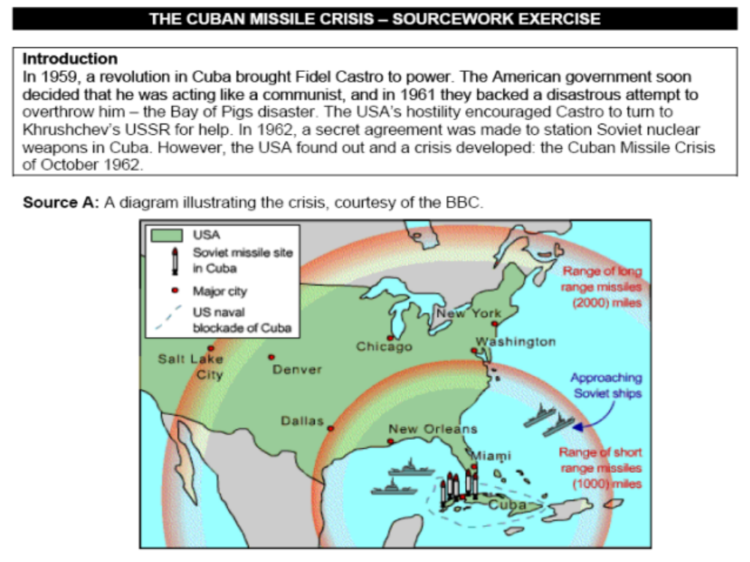 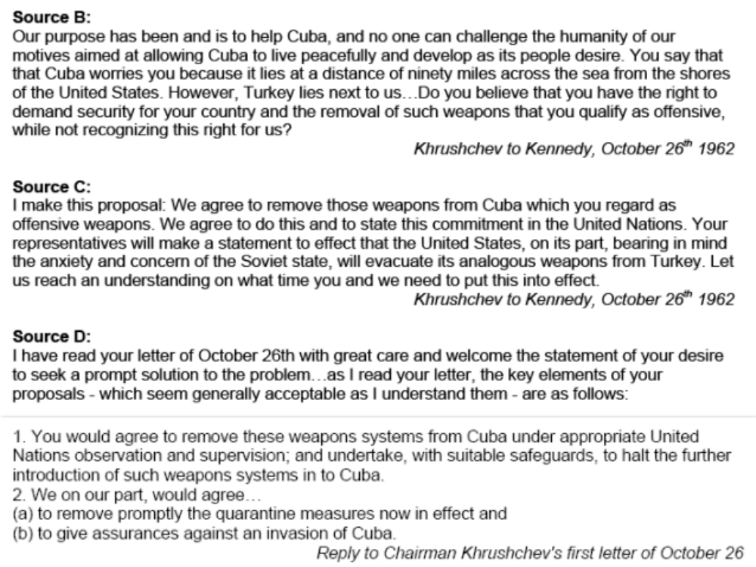 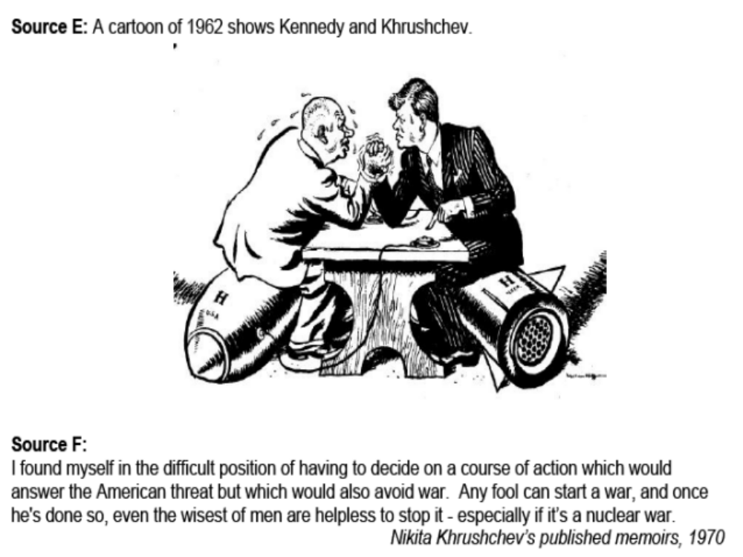 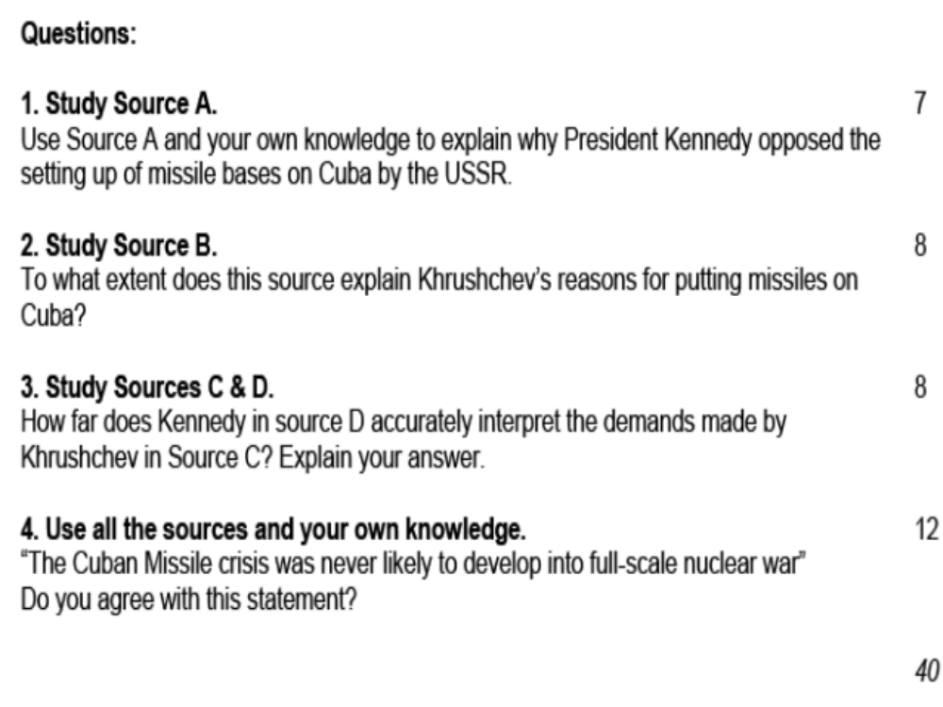

PART III:
DIRECTIONS: Read the following letter from Khrushchev to Kennedy regarding the Cuban missile crisis. Imagine that you are John Kennedy. Write a response to Khrushchev’s letter. How can this crisis be resolved between the two leaders peacefully, while enabling each side to save face?



