Student’s Name:
Date:
Period#:

Ancient Greece Map Quest

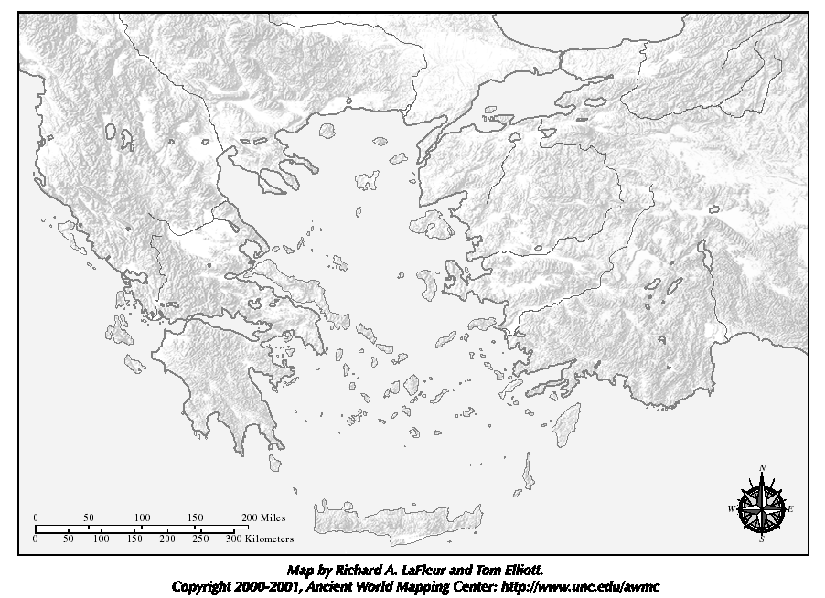

Using your textbook, the Internet, or a good atlas, complete the map quest below:
- Label the map of "Ancient Greece & the Aegean World" as indicated below:
regions {black ink]:Thessaly, Thrace, Macedonia, Peloponnesus, Asia Minor.
bodies of water [blue pencil]:Mediterranean Sea, Aegean Sea, Ionian Sea, Black Sea, Dardanelles Strait.
mountains/peaks [brown pencil]: Pindus Mountains, Balkan Alps, Mt. Olympus.
islands [green pencil]:Crete, Rhodes, Cyclades Islands, Ionian islands, Dodecanese Islands, Aegean islands
cities [red pencil]:Athens, Sparta, Delphi, Thebes, Olympia, Troy, Sardis, Knossus, Byzantium.
peninsulas [purple pencil]: Balkan Peninsula, Peloponnese Peninsula, Anatolian Peninsula.
- What advantages and disadvantages does the geography pose for the ancient Greek peoples?
- Write 3 sentences about how the geography of the area may have shaped Greek life and history?


