NAME:
DATE:
ASSIGNMENT:
PERIOD:

HO CHI MINH: BIOGRAPHY
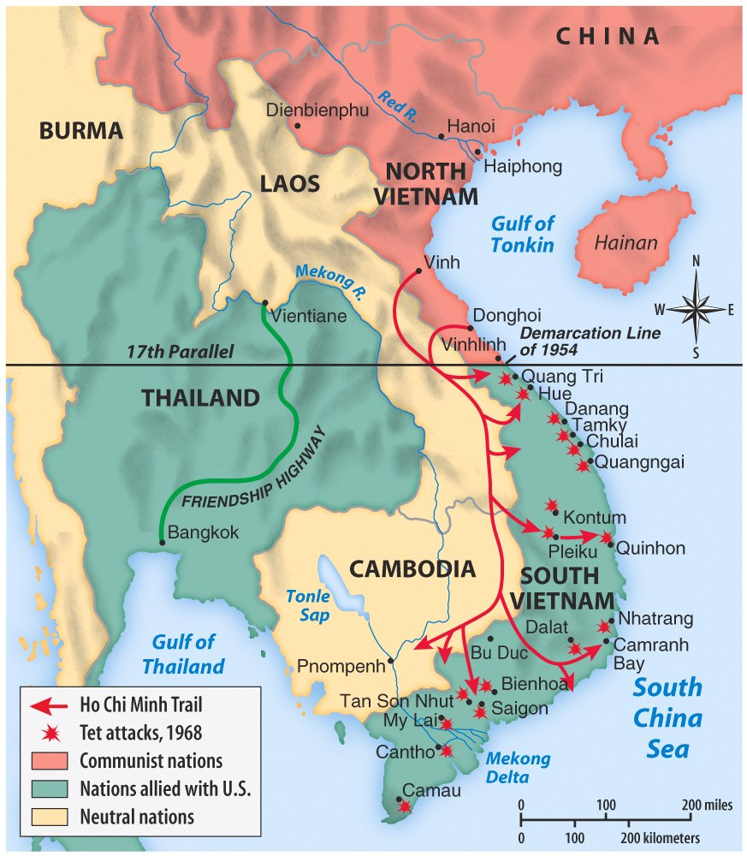

EARLY YEARS
Who controlled Indo-China, (includes Vietnam, Thailand, Laos, Cambodia, and Indonesia) in the late 1800’s and early 1900’s?

Who was Ho Chi Minh’s father? What did he do for a living?

What was the tragedy that struck his family at his early age?

What was Ho’s education like?

What was life like for Vietnamese under colonial rule?

What “revolutionary” act expelled Ho from his education?

TRAVELS ABROAD
What skill enabled Ho to travel abroad? How did he travel? Where did he travel to and finally end up? What impact did these travels have on him?

During his travels in the U.S. , what national icon impressed his greatly? What other aspects of American society “impressed” him?
RISING TO REVOLUTIONARY STATUS
What made Minh head to Paris, France? What was his primary goal while there?

While in Paris, what got Ho banned from returning to his homeland, Vietnam?

Who did Ho think would be a great ally to his cause? Why did he think this?

After being rebuffed, who then did Ho turn to for his cause? Why?

Where did this new partnership take him?

COMMUNIST TIES
What was his first assignment working with the Soviet Union?

What event made him leave China? Where did he go? How did he travel without being detected by the French Imperial Police?

BACK TO VIETNAM
What event made the conditions “just right” for Ho to return to Vietnam?

How long had he been gone from Vietnam?

What does Ho Chi Minh’s name mean?

How did he gain the support of the Vietnamese people?

Why did Ho emerge as the leader of the Revolutionary movement in Vietnam?

What issues did he focus on in order to unite the Revolutionary movement?
1.
2.

What was absent from this message?

WWII comes to Asia
Who invaded Vietnam and much of Asia?

What was Ho’s opinion of this invading force? Could they help him in his drive for independence?

What ally did Ho attempt to make in the fight against the invaders? What was the outcome from this attempt?

How did he get released from prison?

Who did he end up working for?
WWII ENDS
What event ending up allowing Ho’s Vietminh organization to take control of North Vietnam?

What was surprising about the speech that Ho gave at the Independence ceremony?

Why did he do this?

With the Japanese expelled, who was the next threat to Vietnamese independence?

What was Dien Bien Phu?

After France was defeated, what new ally did North Vietnam have? Why did Ho try to play down this alliance?

GENEVA PEACE AGREEMENT
What was the Geneva Peace Agreement? What did it do to Vietnam?

Who was Ngo Dinh Diem?

What caused further fighting to break out again in Vietnam? Who was the fight against this time?

When did Ho Chi Minh die?

What two firsts did Ho give to the United States?

What lesson does the film state that the United States could learn from Ho Chi Minh?

What was Ho’s major achievement?

