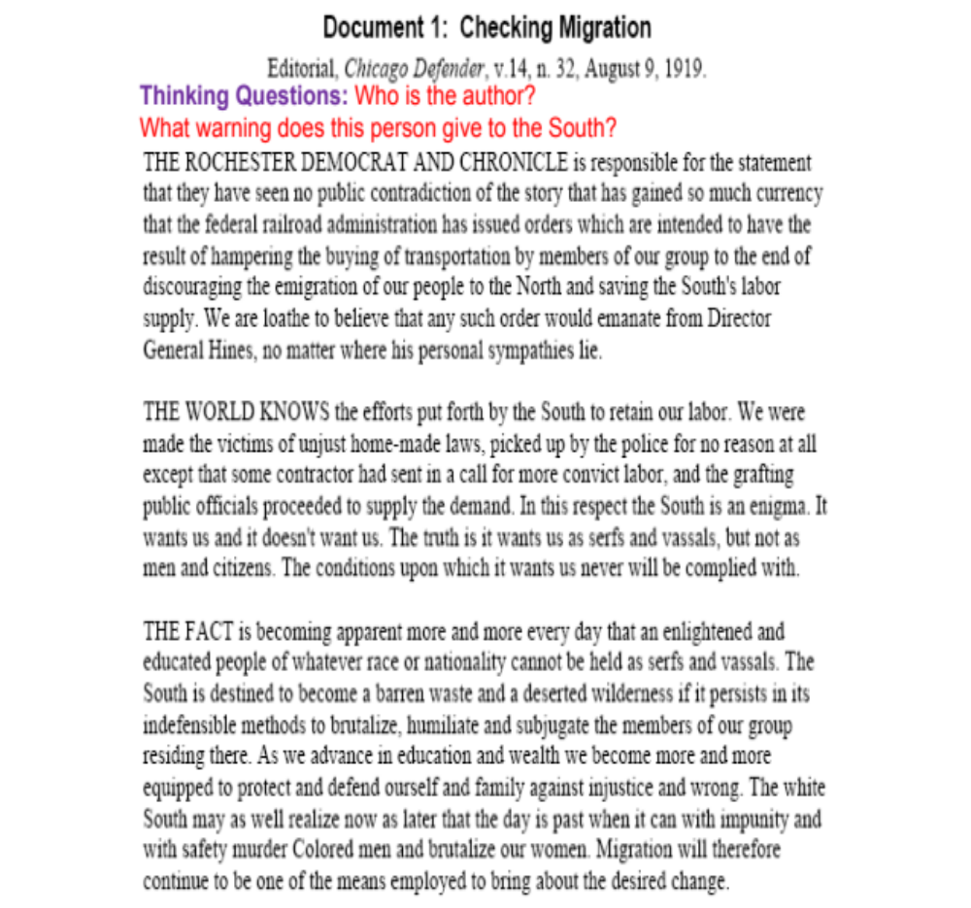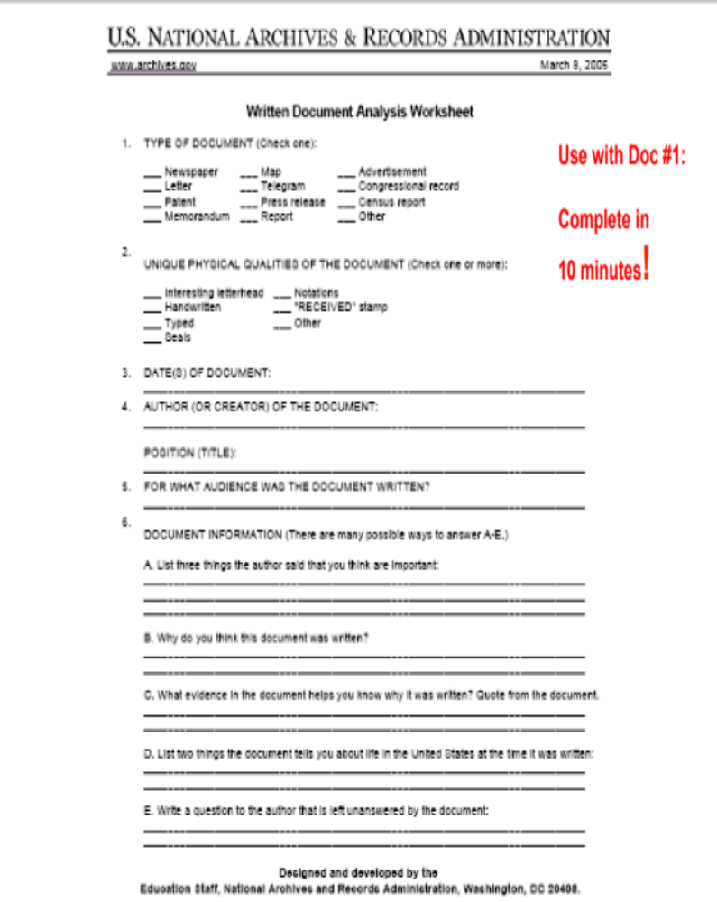
ADDITIONAL QUESTIONS:
1.What reasons does the author give for African Americans heading North?

2. What problems will this movement cause for the South?

3. What is the author’s opinion on this matter?

