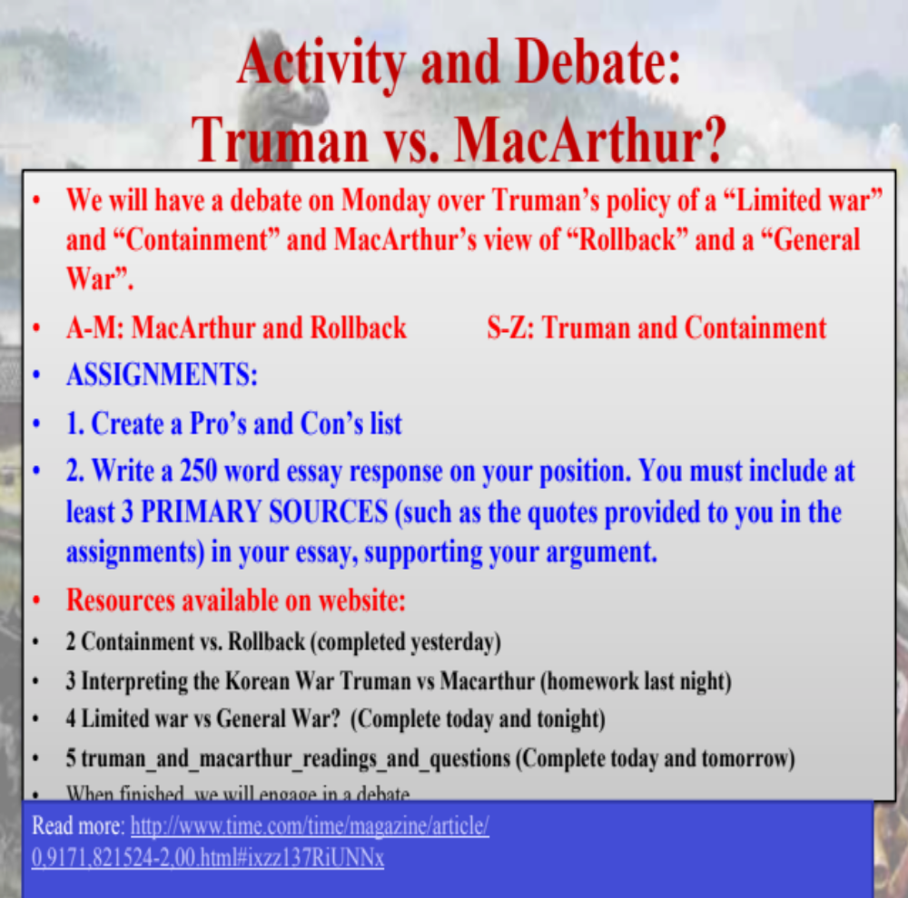
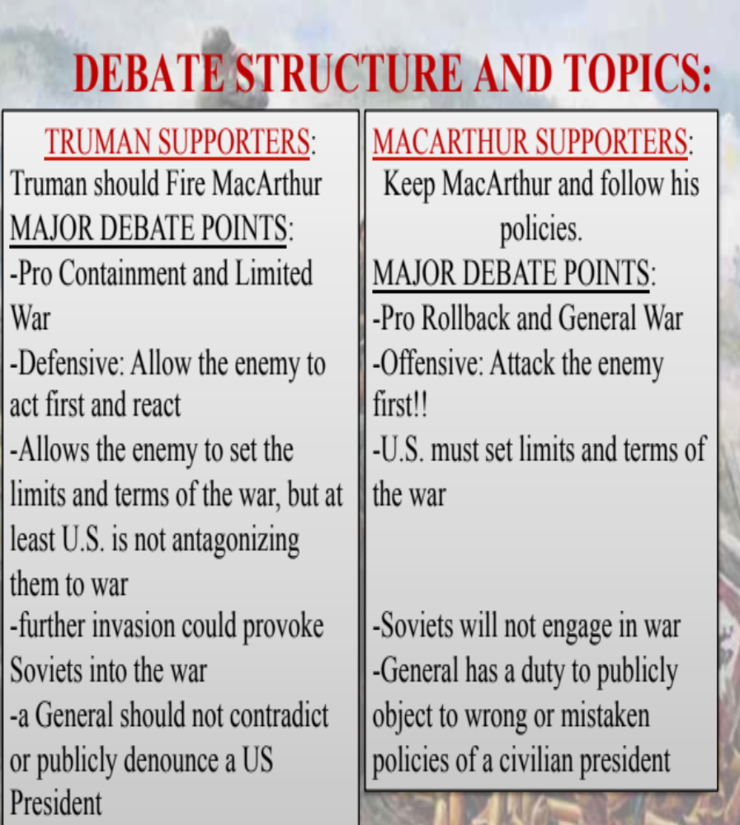
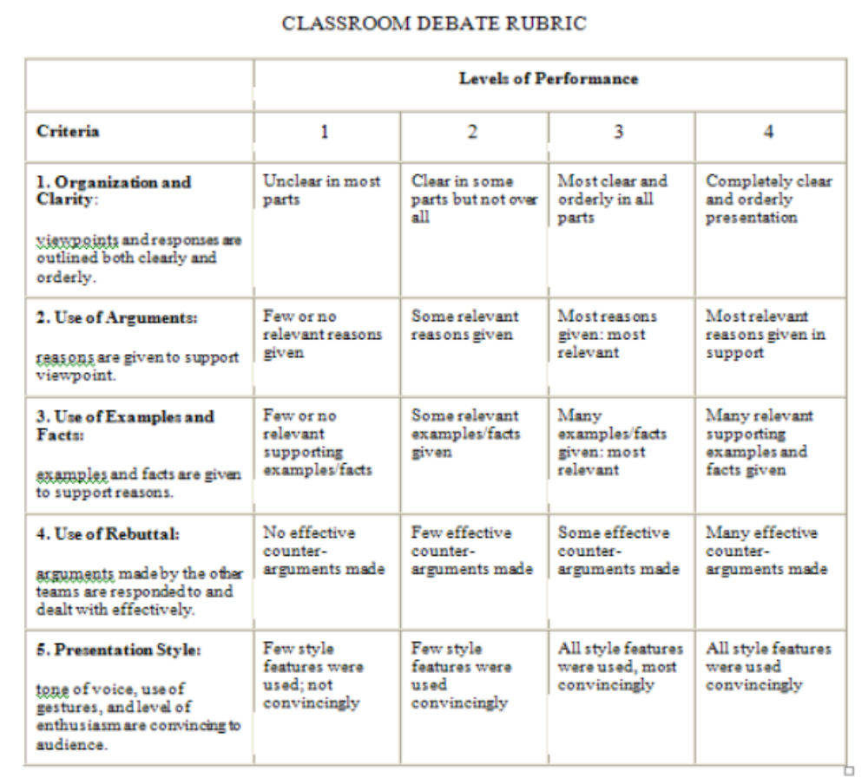

TRUMAN: CONTAINMENT
PROS | CONS
Less chance of Nuclear war | Can create bitterness which could erupt into war later, or even civil war,
Less casualities | Just a theory: not been proven  Will it even work?
Keep Communism from spreading | Do not stop Communism outright
Resources: people, money etc. not wasted | Use taxpayer money to build up economies of Western Europe: Marshall Plan
Keep peaceful relations between countries | Not as effective, because still can spread
 | Too passive, too weak, too soft; letting the enemy set the terms

MACARTHUR: ROLLBACK
PROS | CONS
Quicker solution; gets rid of it | Loss of more life
Zero tolerance policy: established firm rules of engagement | China and Russia get into the war: WWIII
After Communism is out, can place democratic govt in | Possibility of failure; Possibility of Nuclear war
Can be proactive, engage, start to eliminate | But does war work? Is war the answer?
 | War costs money and resources

